Task 3: Login System with Validation
Description: Develop a Login Page:
Validate inputs using JavaScript
Check credentials from database
Show error messages dynamically
Real-Time Usage: Authentication systems for any web application.
give proper codes
Aim
To develop a login system that validates user inputs using JavaScript, verifies credentials from a database using PHP, and displays error messages dynamically.
Algorithm
- Create a database table to store user credentials
- Design login form using HTML
- Validate inputs using JavaScript
- Send form data to PHP
- Connect PHP to MySQL database
- Check username and password using SQL query
- Display success or error message
Program:
1. index.html (UI)
<!DOCTYPE html>
<html>
<body>

<h2>Register</h2>
<form action="register.php" method="POST">
<input name="username" placeholder="Username"><br>
<input name="password" type="password" placeholder="Password"><br>
<button type="submit">Register</button>
</form>

<h2>Login</h2>
<form action="login.php" method="POST">
<input name="username" placeholder="Username"><br>
<input name="password" type="password" placeholder="Password"><br>
<button type="submit">Login</button>
</form>

</body>
</html>
2. register.php
<?php
$conn = new mysqli("localhost", "root", "", "login_db");

$username = $_POST['username'];
$password = $_POST['password'];

$sql = "INSERT INTO users (username, password) VALUES ('$username', '$password')";

if ($conn->query($sql)) {
echo "Registered Successfully";
} else {
echo "Error";
}
?>
3. login.php
<?php
$conn = new mysqli("localhost", "root", "", "login_db");

$username = $_POST['username'];
$password = $_POST['password'];

$sql = "SELECT * FROM users WHERE username='$username' AND password='$password'";
$result = $conn->query($sql);

if ($result->num_rows > 0) {
echo "Login Success";
} else {
echo "Invalid Login";
}
?>
Output:

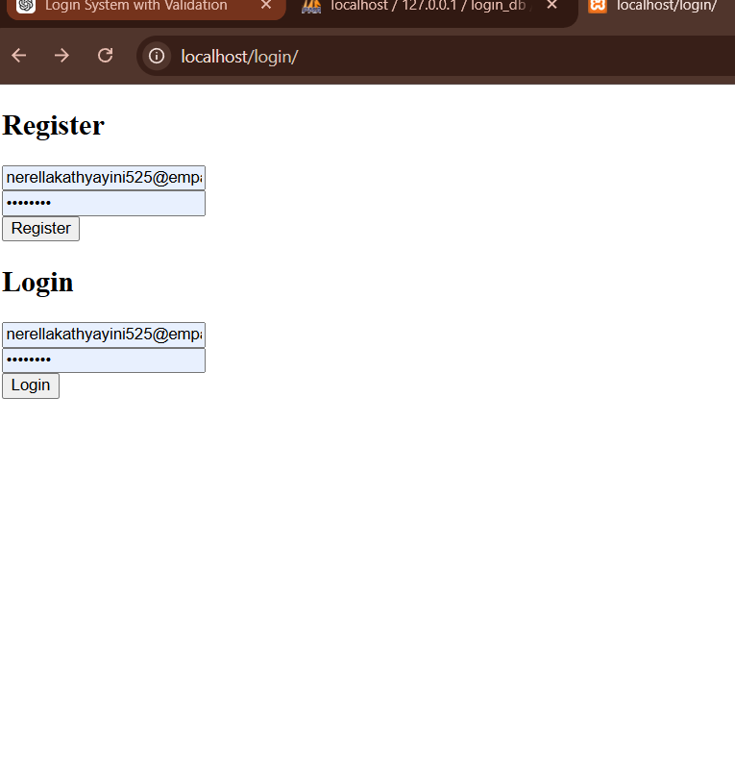

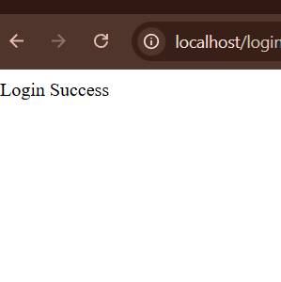

Result:
The dashboard successfully displays student records with sorting and filtering options.
It also shows the count of students in each department using SQL aggregation.

